HW 9 Worksheet – Maximo Antigua

Add a screenshot of the source code of the Project 6-1.html file obtained after completing Project 6-1

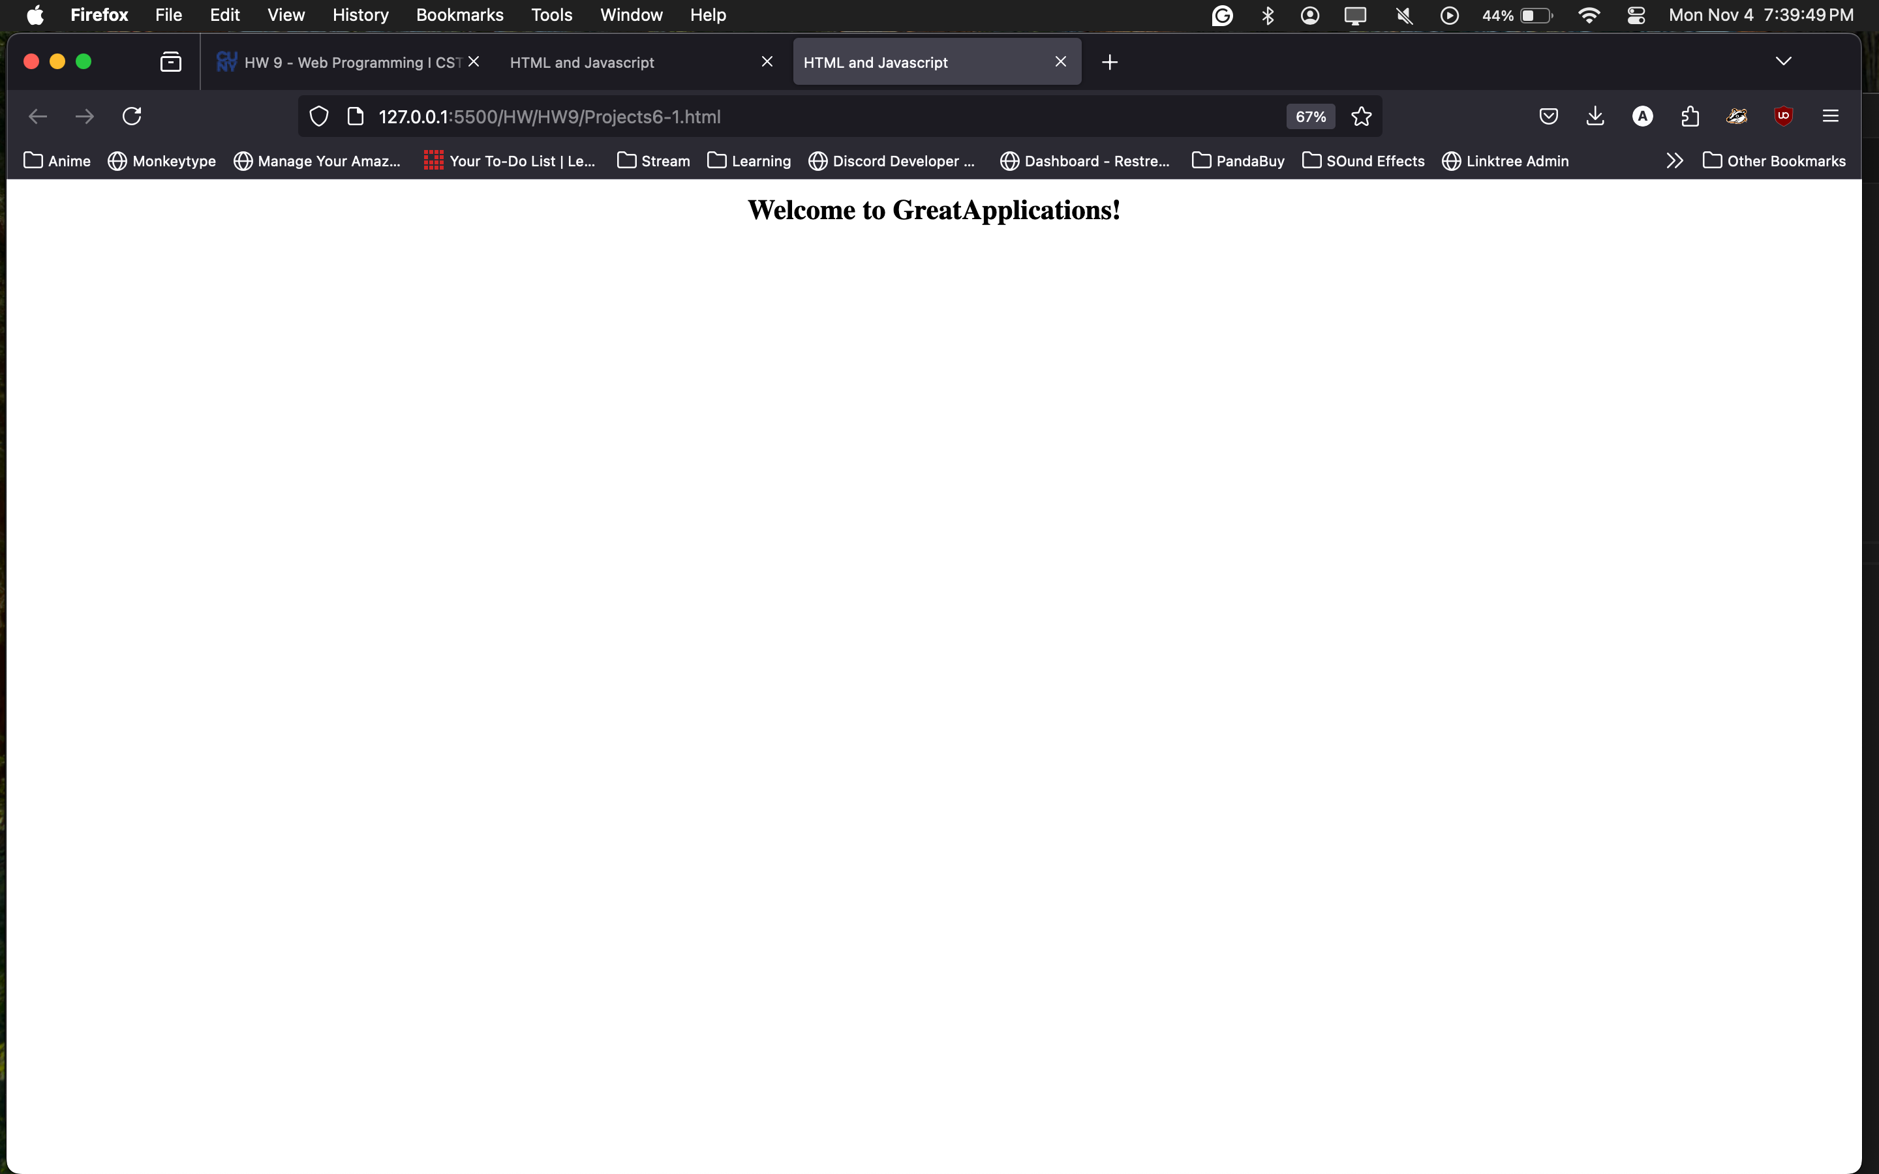

Add a screenshot of the Project 6-1.html file displayed in a browser after completing Project 6-1

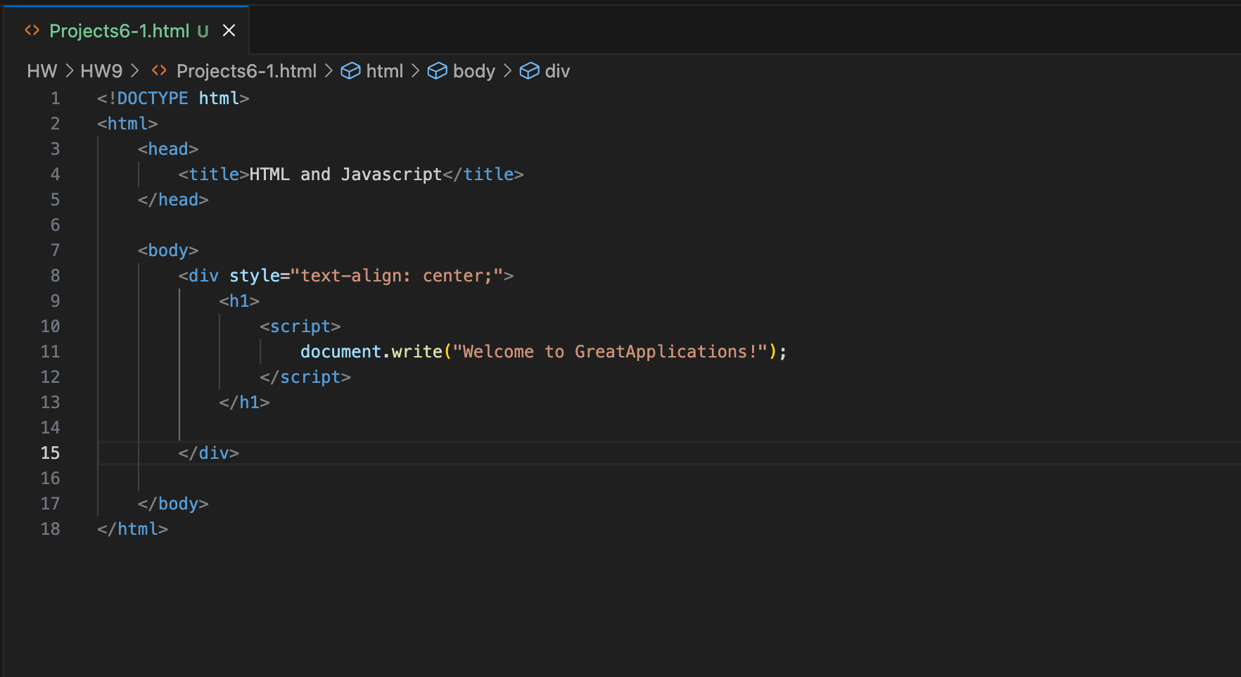

Add a screenshot of the source code of the Project 6-2.html file obtained after completing Project 6-2

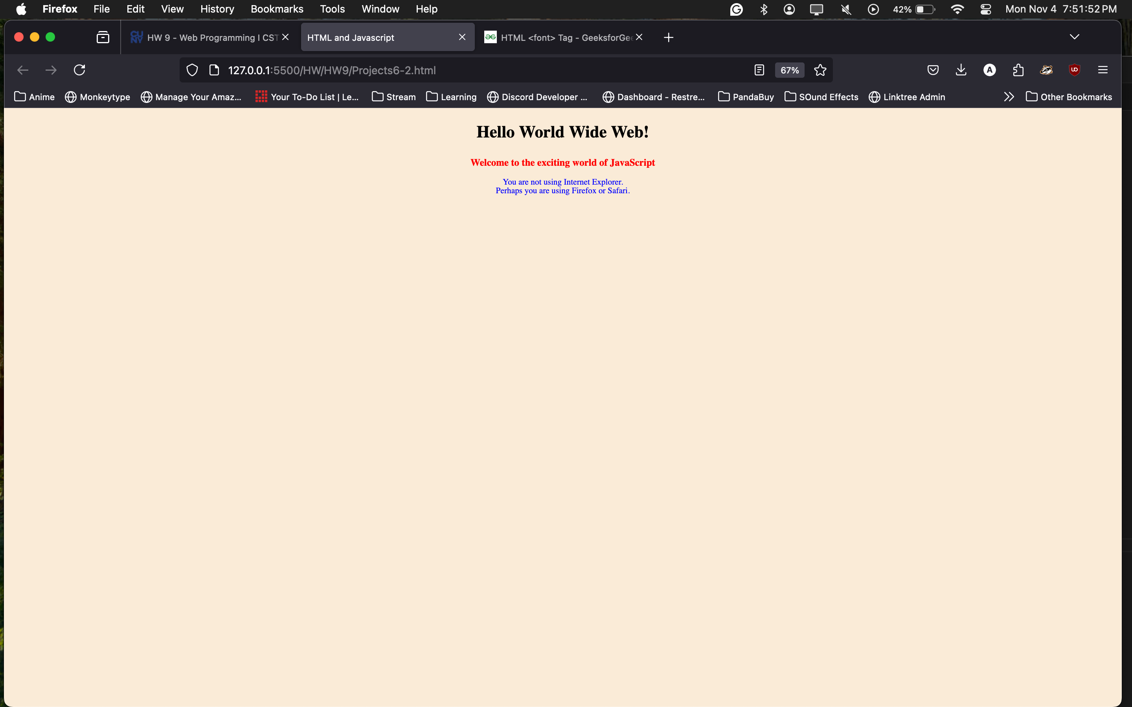

Add a screenshot of the source code of the Project 6-2.html file obtained after completing Project 6-2

